

A Case for Nuclear

By Anthony Rondinelli



Data Source: Global Power Plant Database from the World Resources Institute

The Department of Mathematics, Physics, and Statistics, Azusa Pacific University

Stat 598: Statistical Consulting Practicum

Dr. Seoun Kim

April 28th 2023

**Executive Summary of Project and Results (1 page)**

My objective through analysis is to find the best source of energy to power the future and hopefully make a case for nuclear power. As previously mentioned, this proposal is meant to educate the reader on nuclear energy and to add to the conversation by comparing different fuel types in terms of the number of gigawatt-hours of electricity they generate annually. Through this paper, I hope to provide a comprehensive overview of the benefits and utility of nuclear power. This will include an explanation of how nuclear energy is generated, how nuclear energy and electricity in general is made, the cost of nuclear energy, how safe and clean it is compared to other fuel types, and other miscellaneous information. Additionally, I will compare the output of different fuel types to see which one generates the most electricity.

As a Result of the

Table of Contents

**Type chapter title (level 1)1**

Type chapter title (level 2)2

Type chapter title (level 3)3

**Type chapter title (level 1)4**

**Type chapter title (level 1)4**

Type chapter title (level 2)5

Type chapter title (level 3)6

**Introduction to the Project (including the justification for the project; clearly state goals of the project and explain any underlying hypotheses that shaped the experimental design)**

**(3 pages)**

In order to have the energy to power our tech of the future along with conserving our environment, we have to find a reliable cost-effective method of generating electricity that also does not damage the environment. This proposal is meant to do two things: to educate the reader on nuclear energy on how viable as an energy source and to add to the conversation by comparing the different fuel types through the amount of energy generated.

The world needs electricity to power all the technology that we have. Thus, we need electricity cheap and readily accessible in order to continue sustaining and growing not only in America but also in every other nation in the world. As countries develop, humanity becomes more globally dependent on energy, and needing a clean energy source to conserve our planet, we need to find a clean, reliable, and economically viable source of energy (Dincer et al., 2015). In fact, an article titled *World Energy Needs and Nuclear Power* from the World Nuclear Association describes how much energy we will be needing to add globally due to urbanization: “Growth in the world's population and economy, coupled with rapid urbanization, will result in a substantial increase in energy demand over the coming years. The United Nations (UN) estimates that the world's population will grow from 7.8 billion in 2020 to around 8.5 billion in 2030 and 9.7 billion by 2050. The process of urbanization – which currently adds a city the size of Shanghai to the world's urban population every four months or so – will result in approximately two-thirds of the world's people living in urban areas by 2050 (up from about 55% at present).” (World Nuclear Association, 2022).

In addition, some countries do not have reliable energy sources and rely on importing their energy from other nations. This has been exacerbated by the Russia-Ukraine conflict, as explained in a quote from the International Energy Agencies’ 2022 World Energy Outlook: “…Extraordinarily high prices are sparking a reappraisal of energy policies and priorities. The Europe-Russia energy relationship lies in tatters, calling into question the viability of decades of fossil fuel infrastructure and investment decisions built on this foundation. A profound reorientation of international energy trade is underway, bringing new market risks even as it addresses longstanding vulnerabilities.” (IEA, 2022).

This leads to the research question for my analysis: Does nuclear energy generate more electricity than other fuel types? Based on my sources, there is a lot of potential for nuclear energy to produce vastly more electricity than other fuel types. If I am able to prove that it generates more than other types, then that result, combined with the research from my literature review, could make a strong case for nuclear power as a source of electricity in the future. This In turn could lead to others viewing nuclear energy as viable and influence policymakers.

**Literature Review**

Section 1: Basics

To begin, there is a multitude of different sources of energy. The types of energy sources are divided into three main categories: fossil fuels, alternatives, and renewables. Petroleum (gasoline, diesel, kerosene, jet fuel), coal, and natural gas are all considered fossil fuels. Despite the terms “alternatives” and “renewables” being used interchangeably, renewables usually refer to solar, wind, hydro, and biofuel (wood, food waste, and manure) whereas alternatives refer to nuclear (Word 101, 2017).

For most methods of generating electricity, a turbine generator set is used to convert mechanical energy into electrical energy. In the case of natural gas, coal, nuclear fission, biomass, petroleum, geothermal, and solar thermal, heat is used to create steam, which rotates the turbine blades. In the case of wind and hydropower, the turbine blades are moved directly by wind and water respectively. Solar photovoltaic panels use semiconductors to convert sunlight directly into electricity (U.S. Department of Energy, n.d.).

Electricity generated is then transferred through a power grid. The power grid is a complex system, not just in terms of engineering, but also in terms of industry, markets, and government regulations. However, the economics of making the energy is mostly driven by initial capital costs and the cost of the fuel. Plants that have high initial costs usually are cheaper to operate. In addition, on a grid, there needs to be a main “base load” power plant that handles most of the grid plus “shoulder” and “peaking” plants that are made to adapt to constantly changing demands. (Blumsack, 2020)

Section 2: Cost

One way the cost of energy is calculated is through a statistic called Levelized cost of energy (LCOE) and it is the statistic used to determine the overall cost of different energy sources. As LCOE is calculated as the sum of the costs associated with a particular energy source over its lifetime, divided by the total amount of energy it produces, it provides a useful metric for comparing the relative costs of different fuel types. In this regard, it is interesting to note that nuclear energy tends to be on par with other energy sources in terms of LCOE, with some renewable sources such as wind, geothermal, and certain types of solar being cheaper.

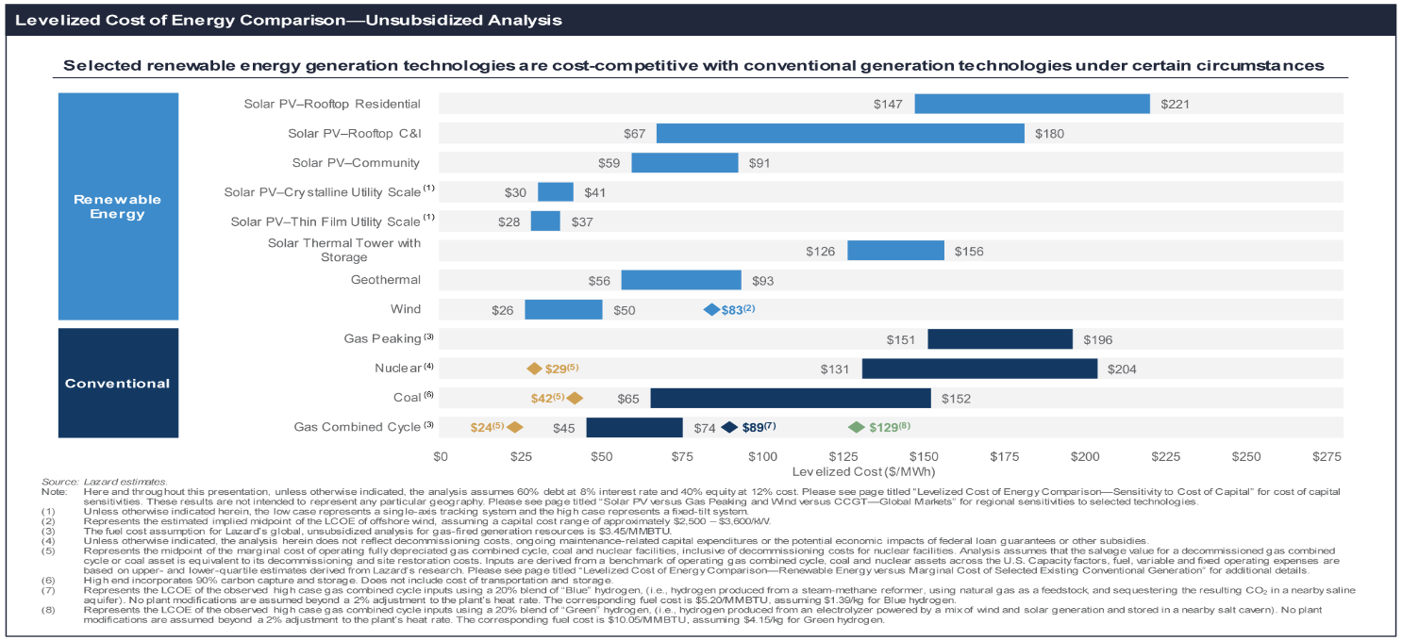There are even real-world examples of countries being powered by nuclear. An example of nuclear being viable to power a country is France. Due to an oil boycott in the 70s, France decided to invest in nuclear till the 90s to become energy independent. After keeping costs low through standardization and careful preparations by the government and the companies, nuclear now supplies 75% of France's energy (Brook et al., 2014).

Section 3: Safety and Cleanliness

There are two different disasters that are spoken about whenever nuclear energy comes up as a topic of conversation: Chernobyl and Fukushima. Usually, these are brought up in order to paint a picture of nuclear energy as unsafe and unreliable. After explaining both of these disasters I will show how safe nuclear can be.

On April 26, 1986, in Chernobyl, scientists ran an experiment on reactor #4, disabling many safety and regulating systems. This experiment and decisions lead to many chain reactions causing multiple explosions. The concrete lid of the reactor was blown off releasing radioactive material into the air. In the following days, the nearby city of Pripyat was evacuated and an exclusion zone was set up around the power plant in an 18-mile radius, due to the radioactive materials spread. The zone was later expanded to around 1,000 square miles, then further expanded to 1,600 square miles. (Britannica, Oct 18, 2022).

The tsunami generated by the Japan earthquake on March 11, 2011, damaged the Fukushima plants’ backup generators. The residual heat from the plant shutting down caused the reactors to melt down. In the following days, multiple explosions went off and an exclusion zone was created 12.5 miles from the plant. Later the area was expanded to 18 miles and thousands were evacuated, which was again expanded to 80 miles months after. (Britannica, Dec 2, 2022).

Despite these disasters that have plagued the nuclear industry in the past, it is still one of the safest and cleanest sources of energy. In fact, when compared to fossil fuels such as coal, oil, and gas, nuclear is just as clean and safe, if not more so. The visual below from Our World in Data clearly illustrates this point, showing the devastating effects of fossil fuels on the environment and human health, in contrast to the relatively low impact of nuclear energy. It is important to note that while there have been incidents in the nuclear industry, the technology has come a long way in terms of safety and reliability; Chernobyl and Fukushima are ultimately outliers and not representative of the reality of nuclear power plants. Furthermore, the potential benefits of nuclear energy in terms of reducing greenhouse gas emissions and mitigating climate change cannot be overlooked.

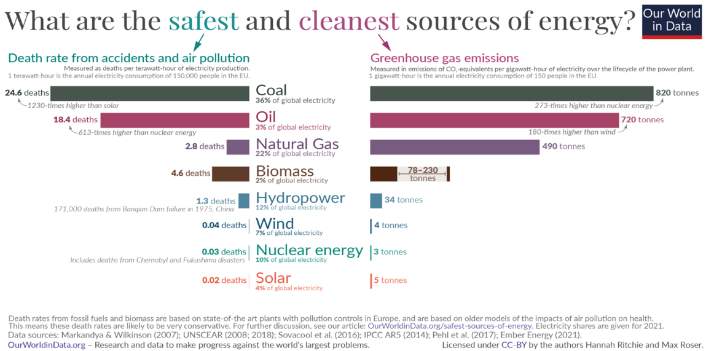

Section: Other

The thing about wind and solar energy is that they have a difficult time supplying our power reliably because they only work intermitted, need other fuel sources to compensate for their intermittence and require redundant investments in capacity for transmission and production. Using these renewable energies like this can actually cause more greenhouse gases to be released into the air than a coal power plant (Brook et al., 2014).

In addition to supplying energy, nuclear can provide a number of other useful goods: “Nuclear energy is not limited to the generation of electricity, but may equally well be used for such important tasks as desalination, production of hydrogen, space heating and process-heat applications in industry as well as for the extraction of carbon from CO2 to combine with hydrogen to create synthetic liquid fuels. Many of these alternative applications of nuclear energy will combine very well with the generation of electrical energy in that the reactors could be operated continuously at full power, allocating the required amount of heat to satisfy the electrical load demand and the rest for producing fresh water, hydrogen or steam for industrial processes.” (Brook et al., 2014).

**Methods**

I did not use an imputation method because the analysis removed all the observations with errors.

my analysis technique for this project is multiple linear regression.

looking into Multi-Level Modeling.

**Statistical Analysis Plan**

The dataset that I am using for this project is the Global Power Plant Database from the World Resources Institute. It is a comprehensive database of nearly 35,000 power plants from all over the world. The database includes detailed information about each power plant, such as its name, location, country, fuel type, capacity, and the number of gigawatt hours of electricity it has generated. The database was compiled from over 600 different sources, and it provides a wealth of information about the global power generation landscape. It is an important resource for researchers, policymakers, and others who are interested in the global energy industry and it continues to be updated regularly to ensure its accuracy and relevance.

Initially, I intended to use multiple linear regression to model the relationship between fuel type, capacity, and gigawatt hours generated for each power plant. However, in order to verify the influence of capacity on the model, I also constructed a simple linear regression model using only fuel type as a predictor variable. The results of this analysis showed a significant change in the model, indicating the importance of considering capacity in my analysis. Further investigation is needed to fully understand the impact of this variable on the relationship between fuel type and gigawatt hours generated. Here is the staggering change that capacity caused:

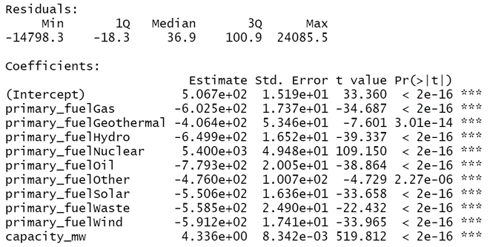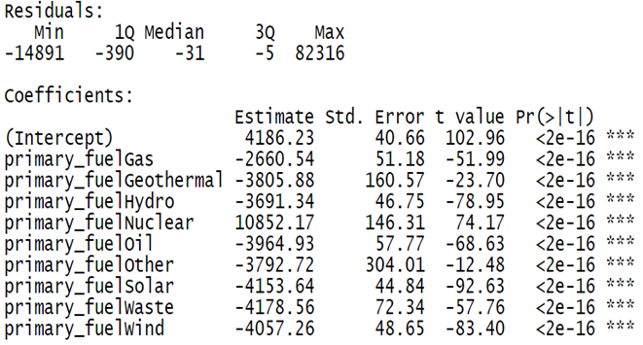

My plan for the next semester is to address the issue of capacities’ influence and investigate the peculiar coefficients in my model. In addition, I hope to find transformations that can improve the accuracy of my data representation and explore other datasets that could potentially be integrated into my model, either as additional variables or as a replacement for my original dataset. Finally, I plan to consult with industry experts to ensure the validity of my analysis and identify any potential gaps. Despite the challenges I have faced, the preliminary results of my model suggest that nuclear energy may indeed be a viable source of electricity. Below is my plan for further research and completion of my project.

**Results**

Below are the results from the multiple linear regression analysis:

Summary table (using Nuclear as the reference category):

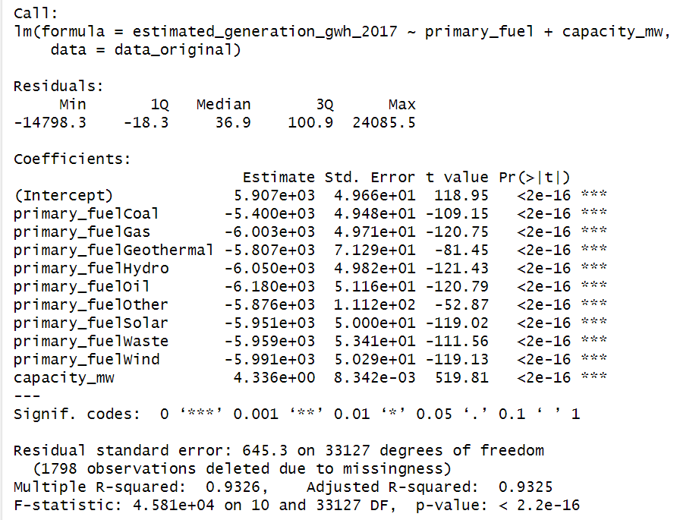

From this, we can tell that both of my variables are significant. Through the

Solar

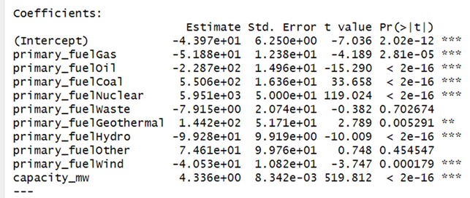

Anova Table:

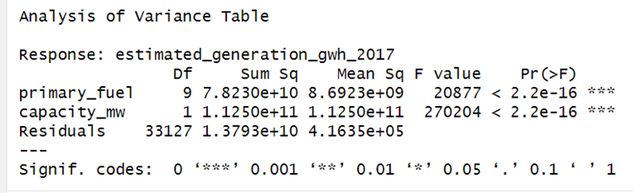

**Discussion of Results (i.e. what the results mean, whether the results are complete, whether the results suggest further work is necessary, and if so what type of follow on work should be done to improve or advance the data). (5-10 pages)**

**Conclusion and Recommendations (i.e. for future practices, practices to be modified/maintained, improvement of productivity, etc. These recommendations should be clearly and concisely written so that the sponsoring company can make easy use of them). (2-3 pages)**

# **References**

1. Blumsack, S. (2020). *Summary and Final Tasks*. EME 801: Energy Markets, Policy, and Regulation. https://www.e-education.psu.edu/eme801/node/528
2. Brook, B. W., Alonso, A., Meneley, D. A., Misak, J., Blees, T., & van Erp, J. B. (2014). Why nuclear energy is sustainable and has to be part of the energy mix. *Sustainable Materials and Technologies*, 1-2, 8–16. https://doi.org/10.1016/j.susmat.2014.11.001
3. Dincer, I., & Acar, C. (2015). A review on Clean Energy Solutions for better sustainability. *International Journal of Energy Research*, *39*(5), 585–606. https://doi.org/10.1002/er.3329
4. Encyclopaedia Britannica. (2022, October 18). Chernobyl disaster. In Encyclopaedia Britannica. Retrieved December 14, 2022, from https://www.britannica.com/event/Chernobyl-disaster
5. Encyclopaedia Britannica, (2022, December 2). Fukushima accident. In Encyclopaedia Britannica. Retrieved December 14, 2022, from https://www.britannica.com/event/Fukushima-accident
6. ExxonMobil. (2022). *Energy demand: Three drivers*. https://corporate.exxonmobil.com/energy-and-innovation/outlook-for-energy/energy-demand?print=true#Transportation
7. IEA. (2022). *World Energy Outlook 2022*, IEA, Paris https://www.iea.org/reports/world-energy-outlook-2022
8. Ritchie, H. (2020, February 10). *What are the safest and cleanest sources of energy?* Our World in Data. https://ourworldindata.org/safest-sources-of-energy
9. U.S. Department of Energy. (n.d.). *Electricity production and distribution*. Alternative Fuels Data Center. <https://afdc.energy.gov/fuels/electricity_production.html>
10. World 101. (2017). *Sources of Energy: A Comparison*. World 101. https://world101.cfr.org/global-era-issues/climate-change/sources-energy-comparison
11. World Nuclear Association. (2022, October). *World Energy Needs and Nuclear Power*. World Nuclear Association. https://world-nuclear.org/information-library/current-and-future-generation/world-energy-needs-and-nuclear-power.aspx